# Advanced Software Engineering

## Assignment3

## WCF Restful service & Mash up

Student Details:

Sivakumar Pothala

16148142

Computer Science

# Restful service

Installing IIS Server

1. Open Manager window

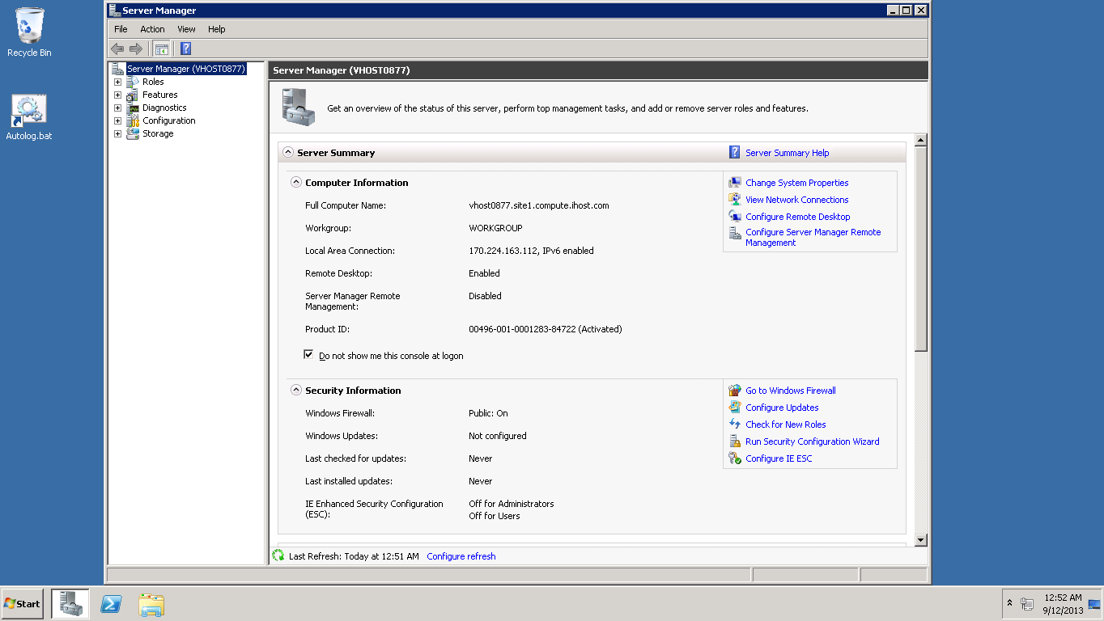

1. Adding roles

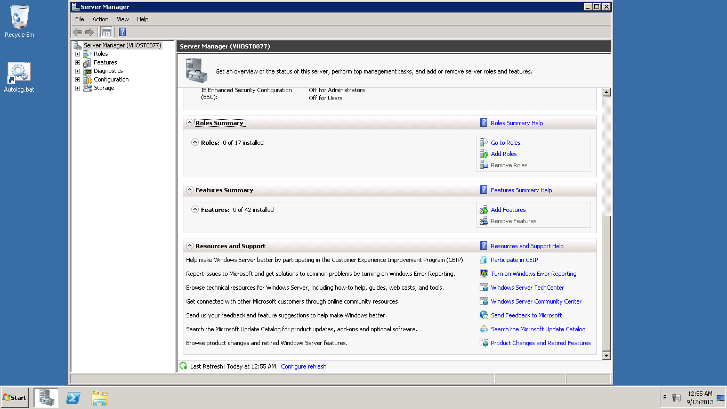

1. Selecting server role Web Server (IIS)

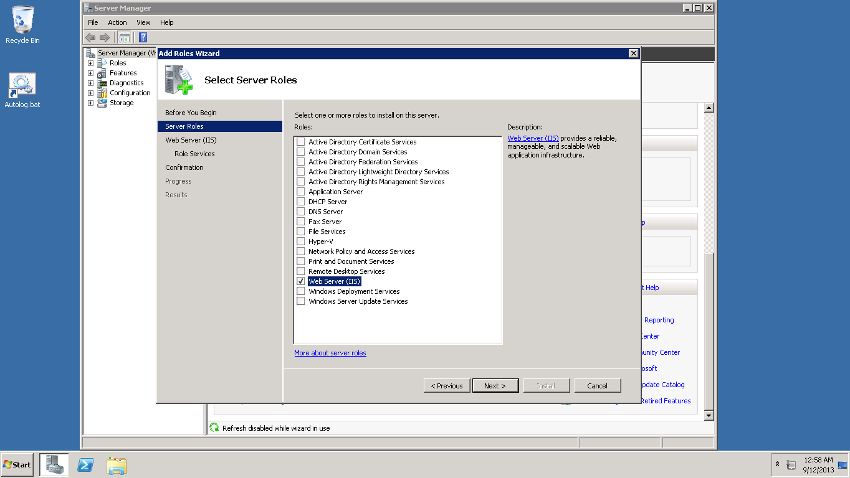

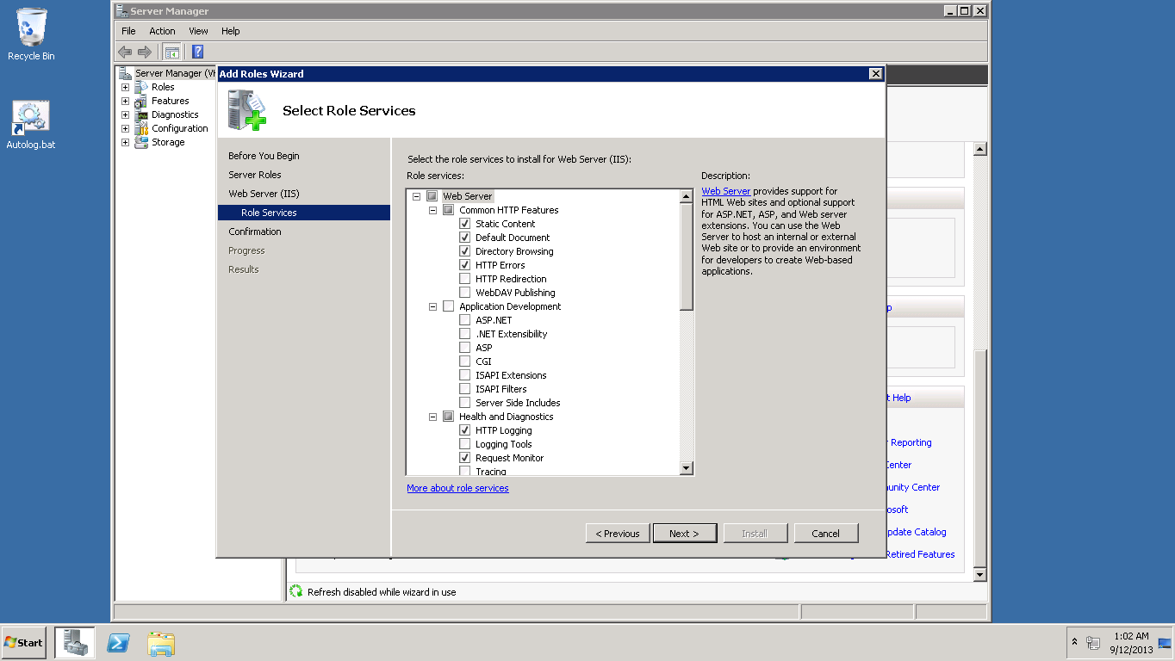

1. Installation Process

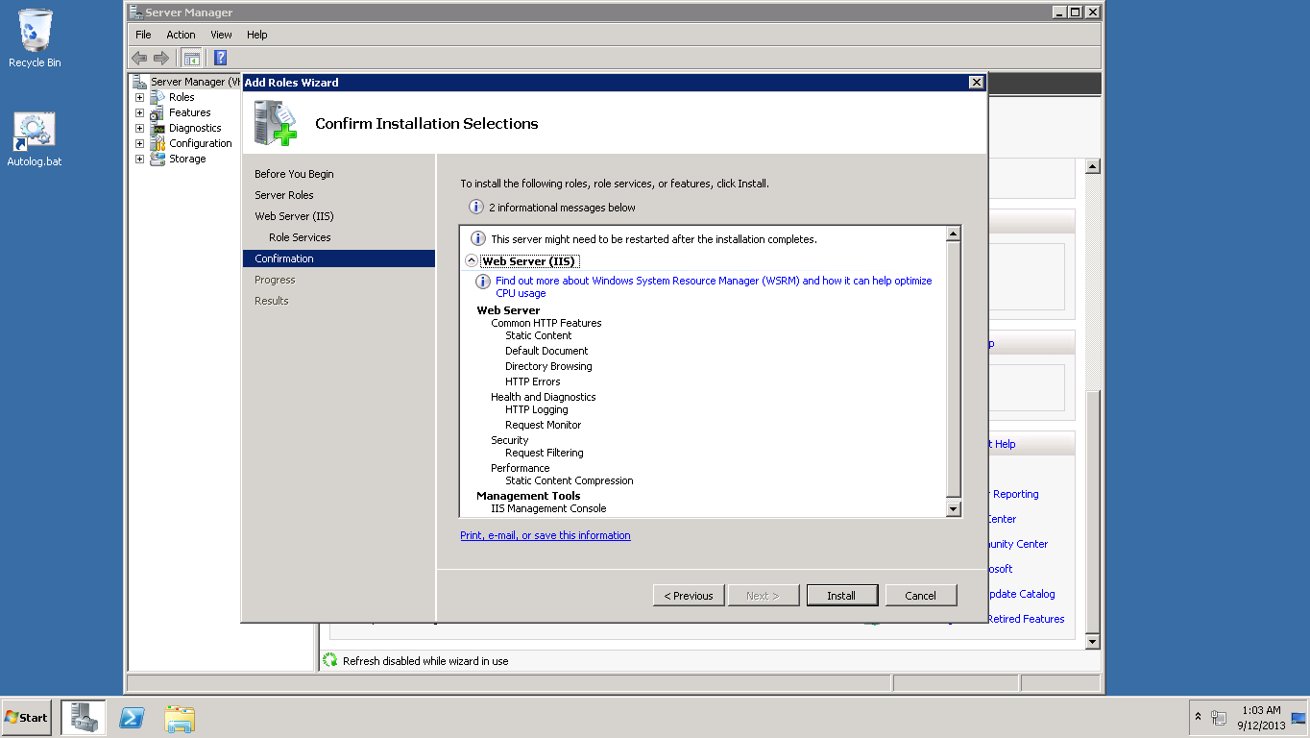

1. Installation successful

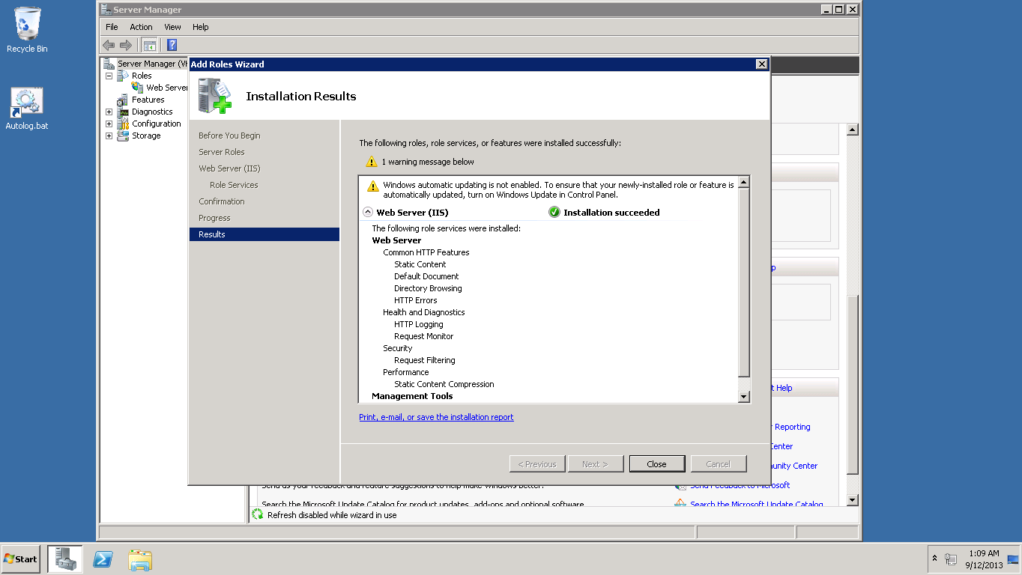

1. View by small icons

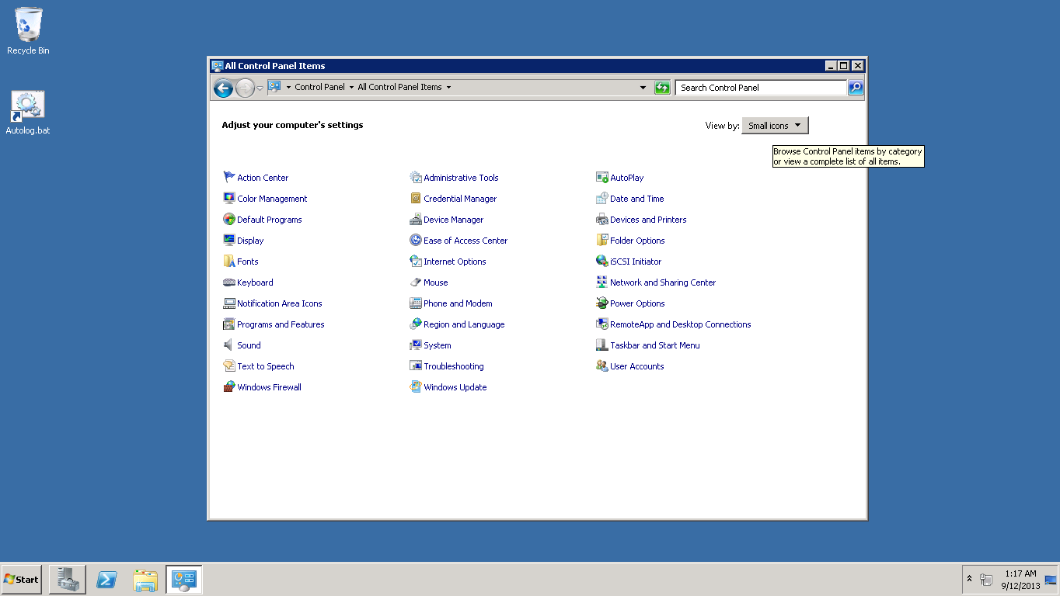

1. Setting up Windows Firewall

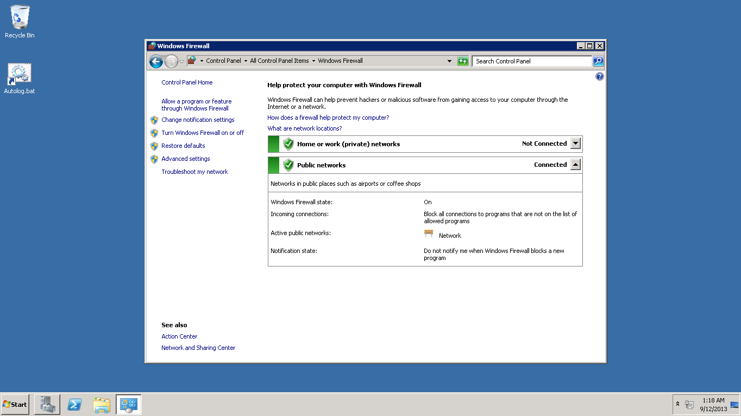

1. Firewall has been set to World wide web Services (HTTP)

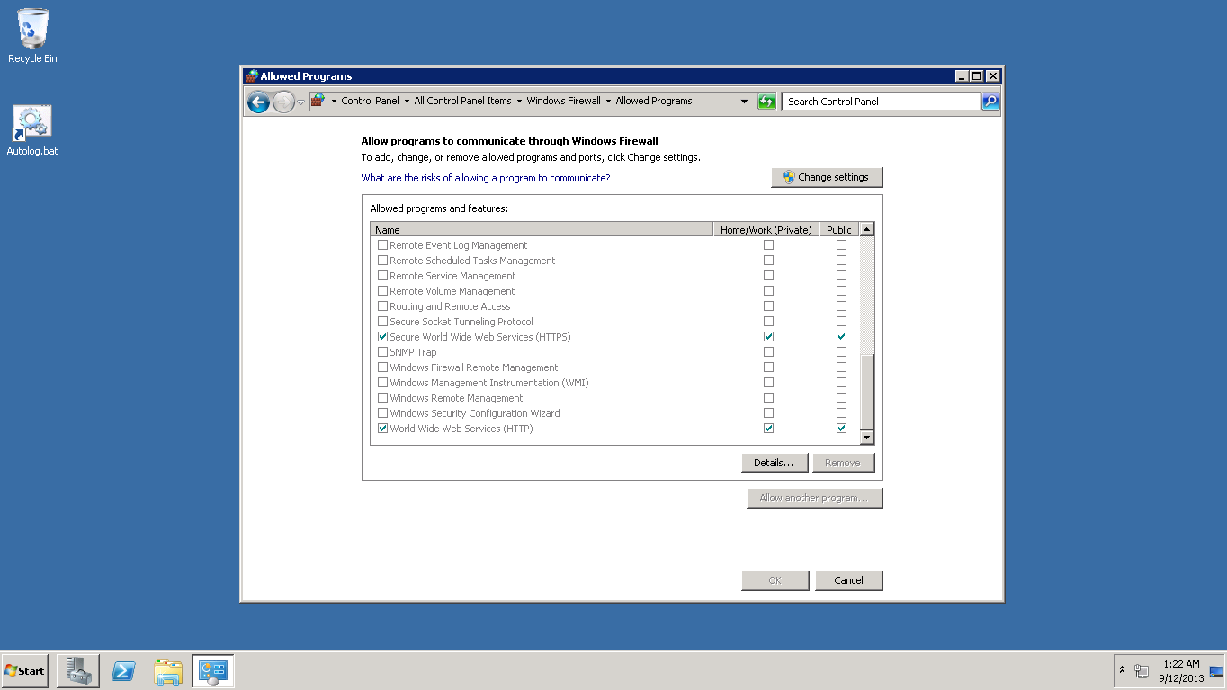

1. Changing Application host Configuration

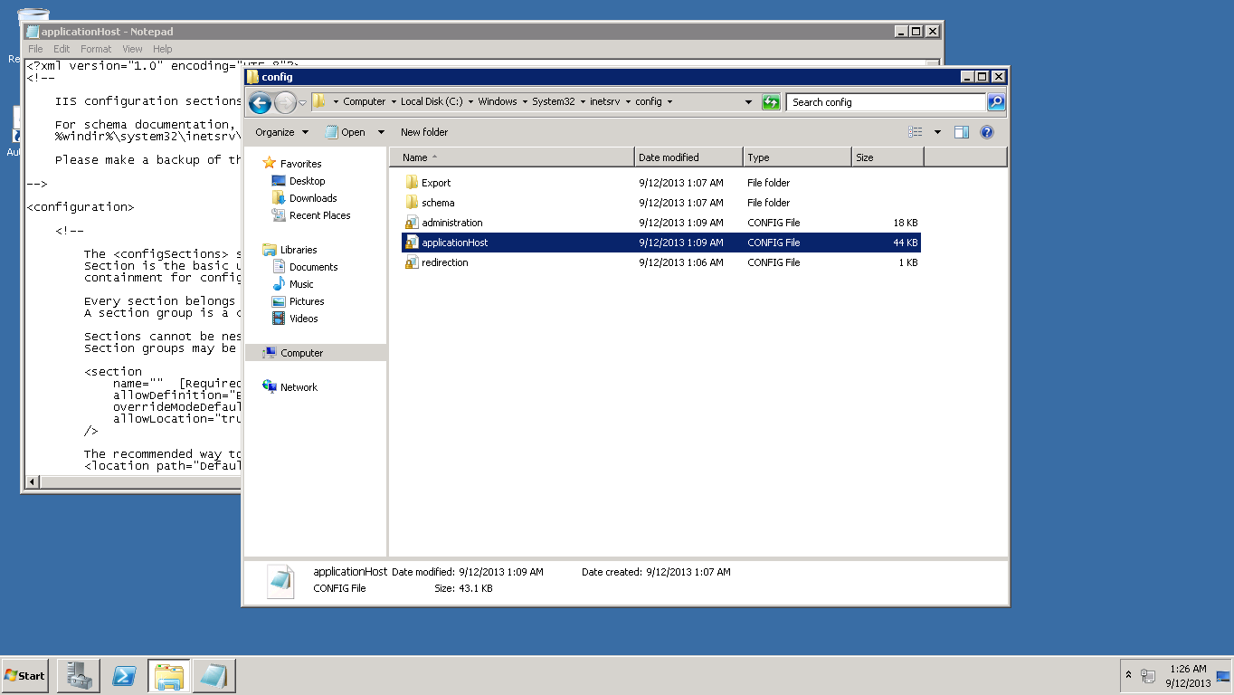

1. Application host opened in the notepad

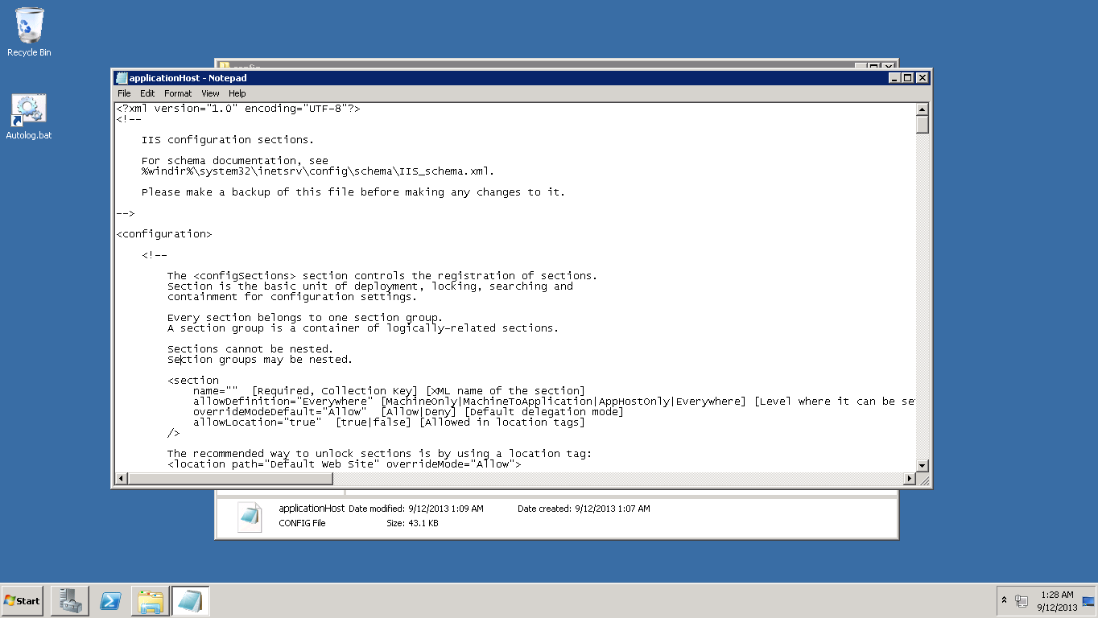

1. Changing override permissions for handlers and modules

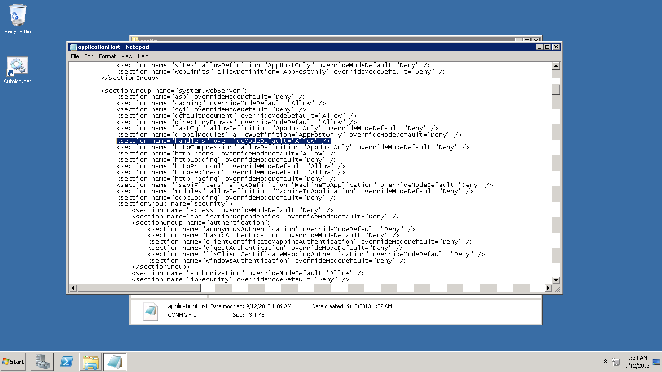

1. Selecting Features

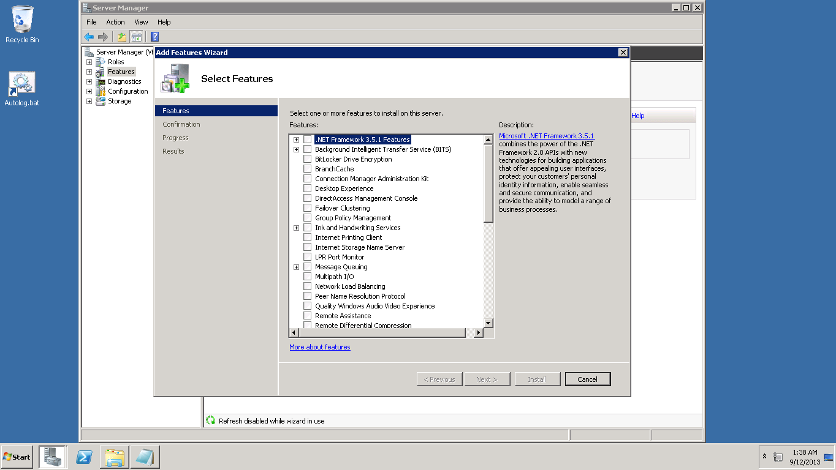

1. Adding .NET Framework 3.5.1 Features

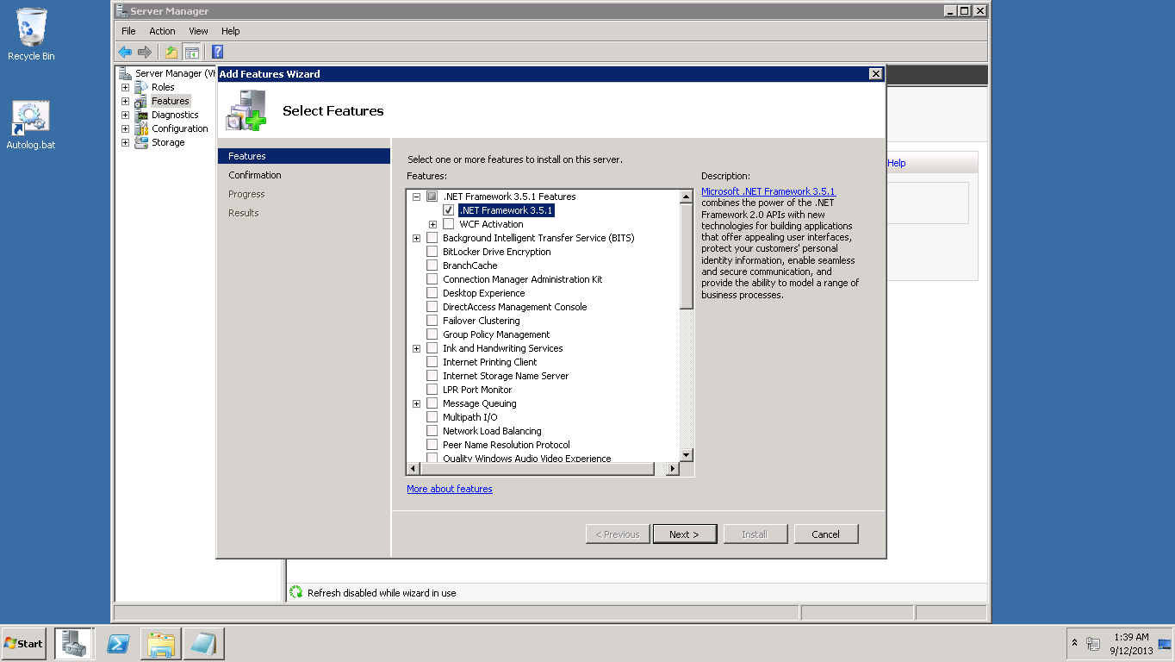

1. .NET Framework Installation successful

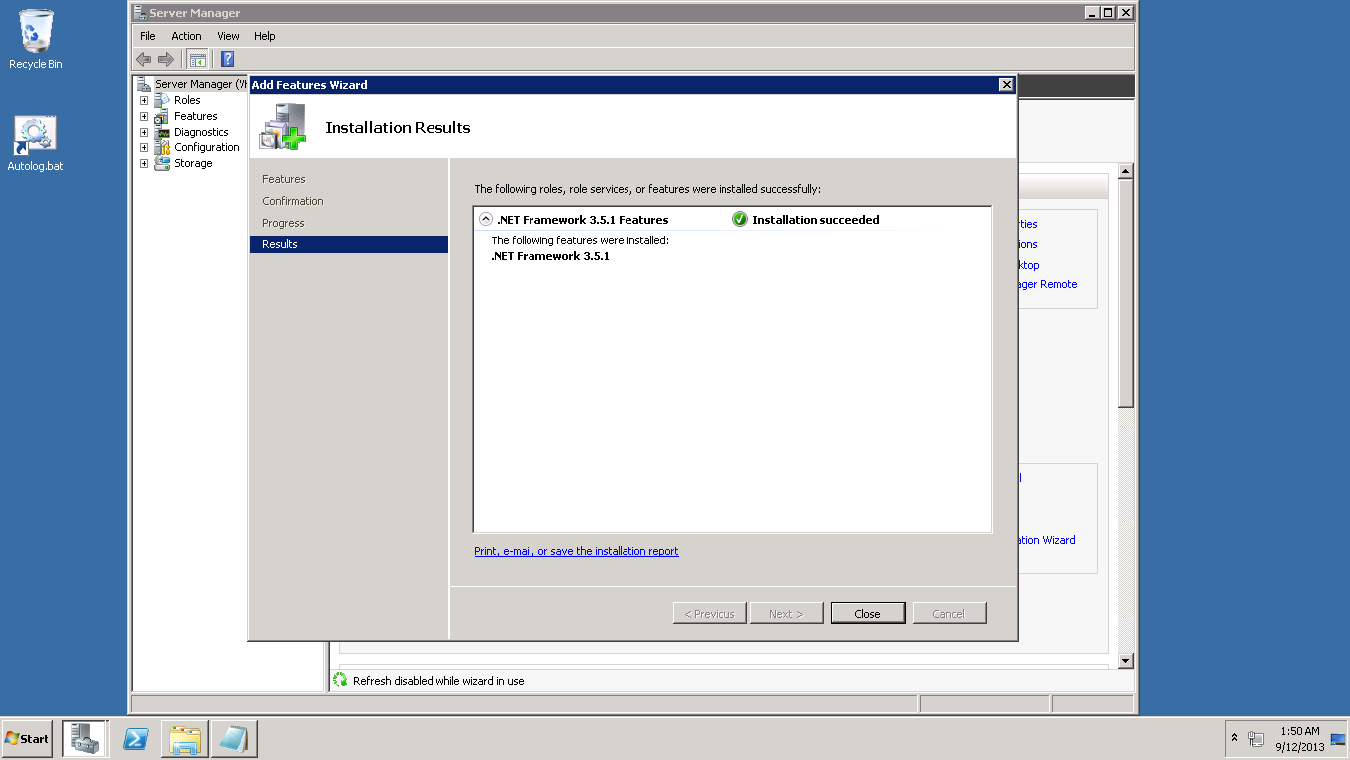

1. Windows Power shell run as administrator

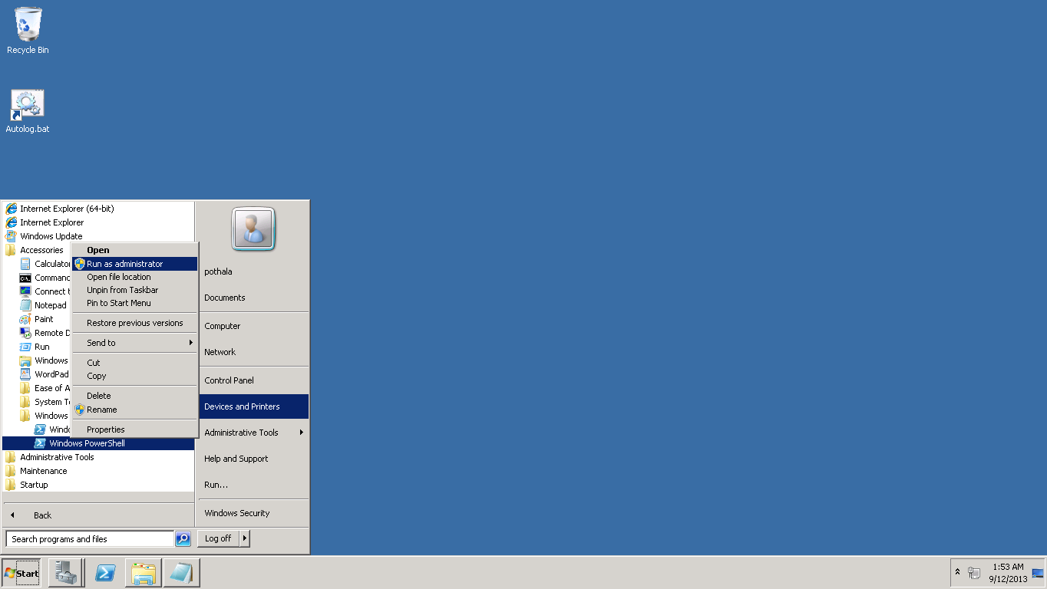

1. Added commands in power shell

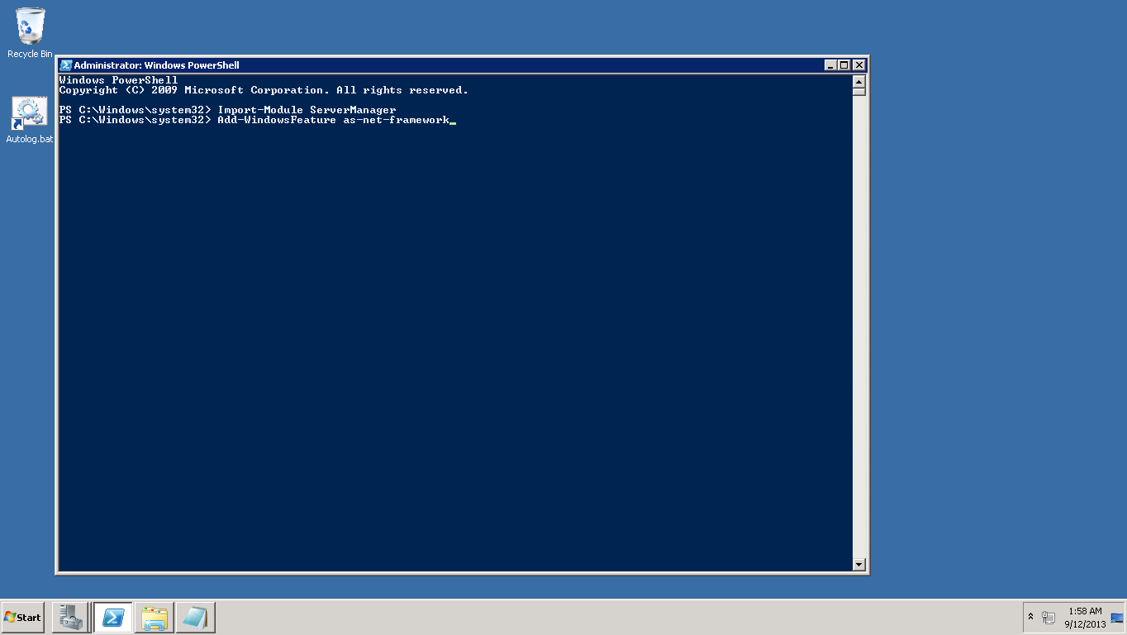

1. Shows successful run status

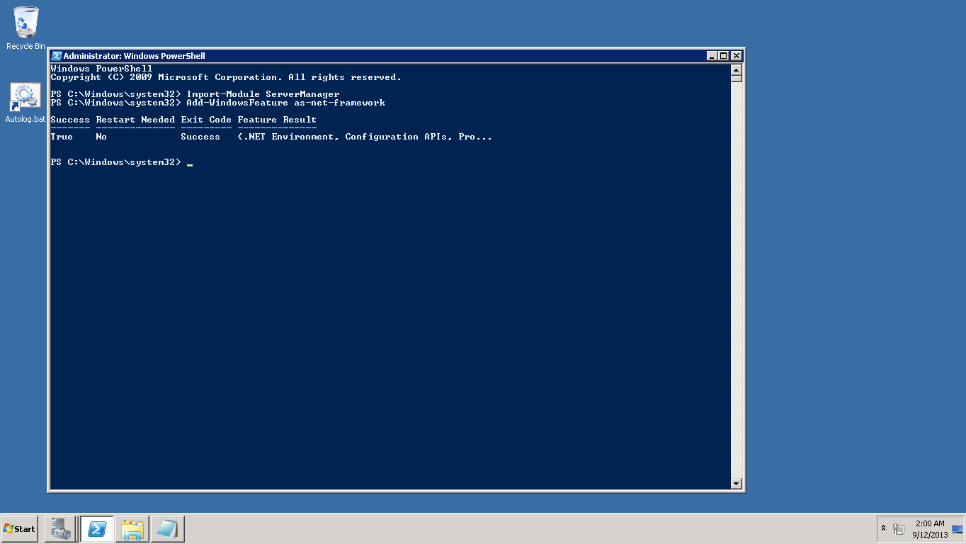

1. Installing Microsoft Web Installer 4.6

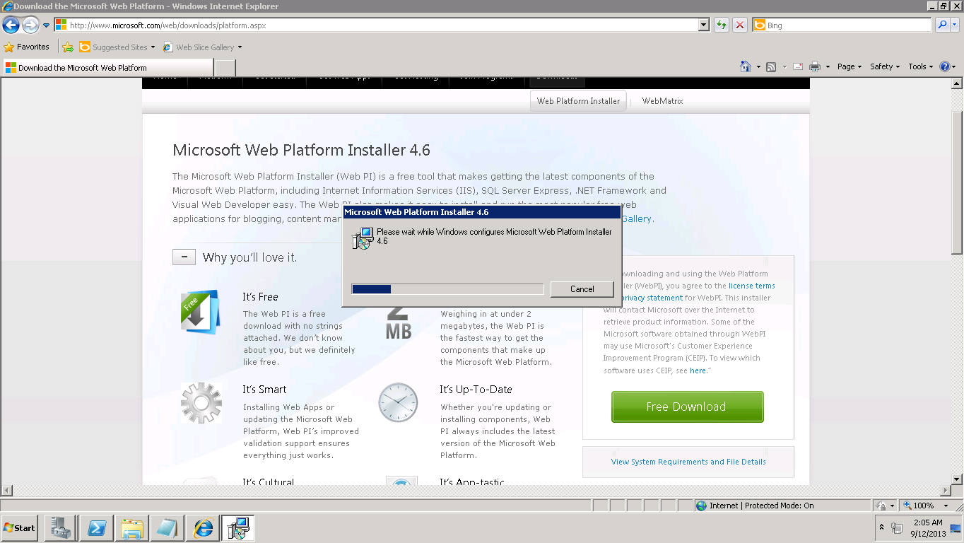

1. Adding IIS Recommended Configuration

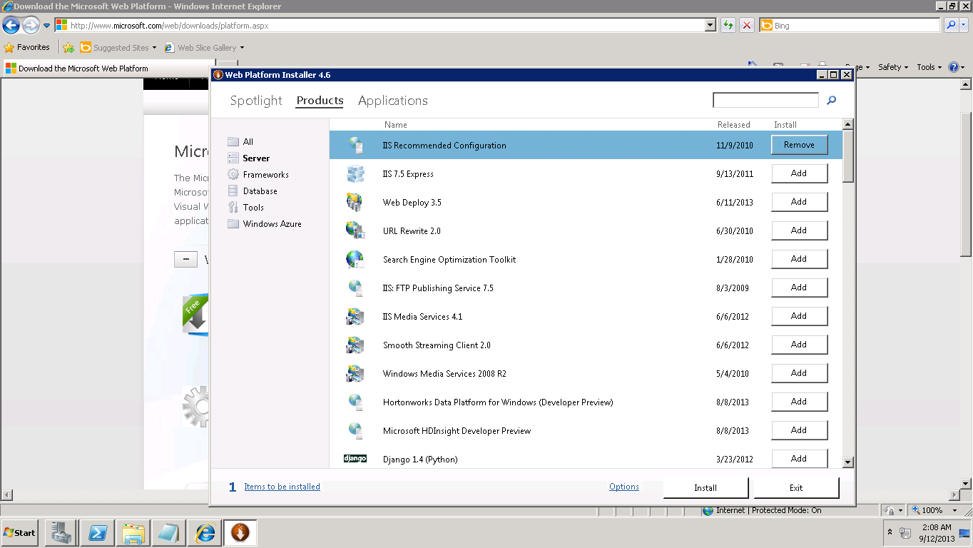

1. Added Visual studio and .NET Framework 4.5

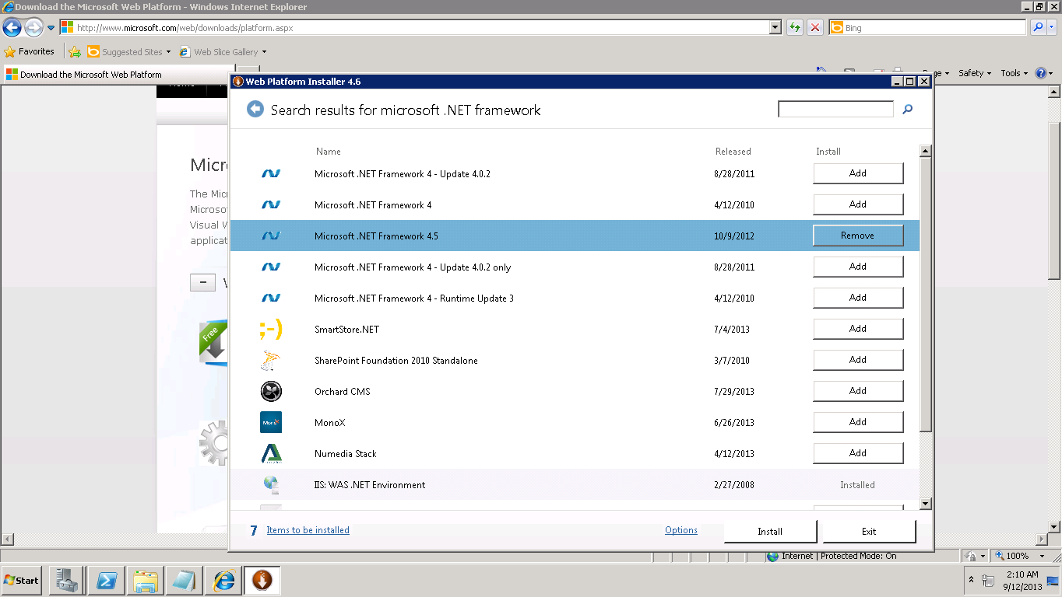

1. Installation Successful

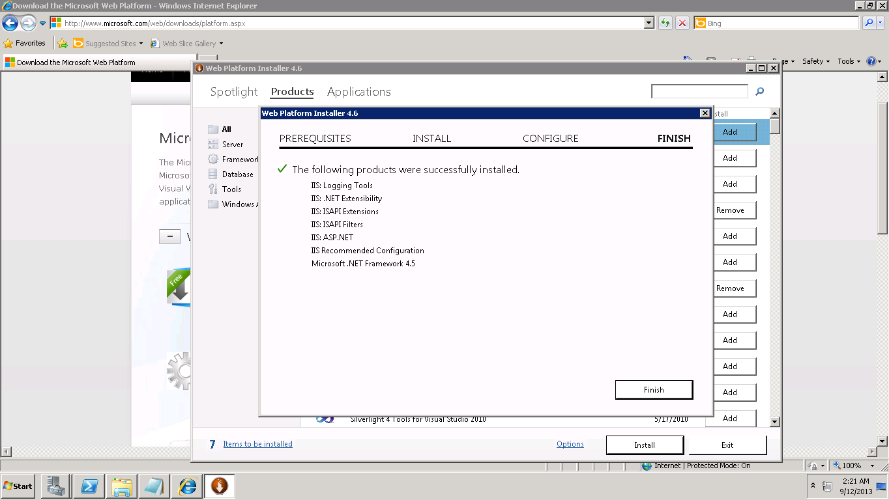

1. Converting WcfService1 to Application

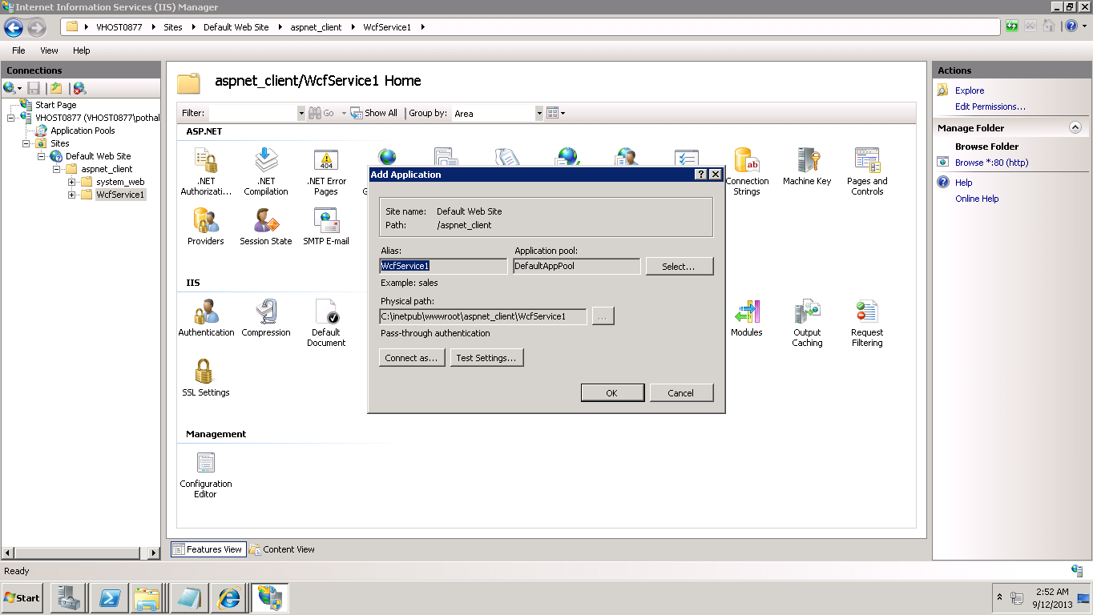

1. Content view of Service1

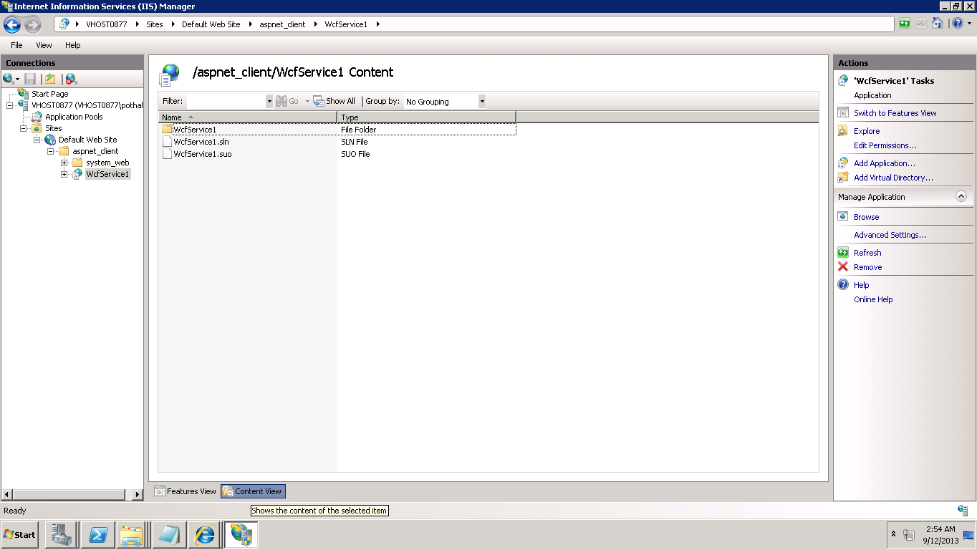

1. Adding Full control permissions to "IIS_IUSRS" group.

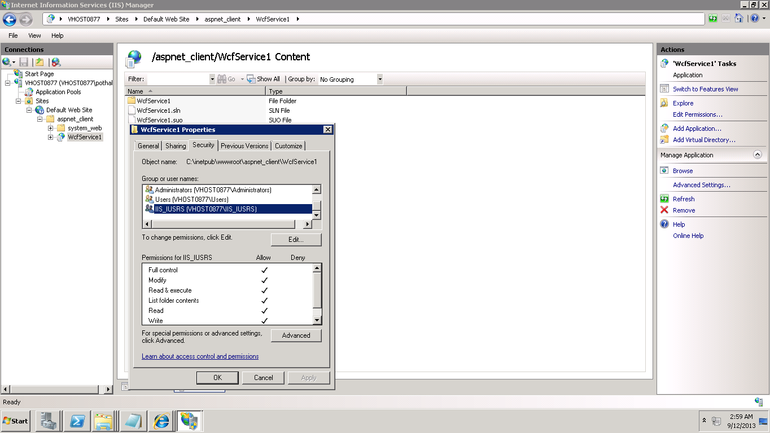

1. Changing Application pool to ASP .NET 4.0

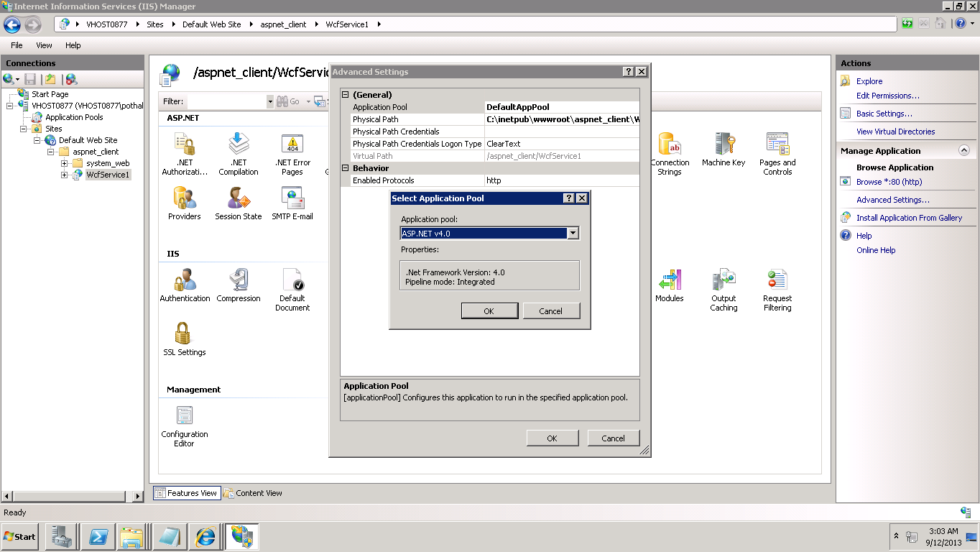

1. After running this service it returned a JSON file

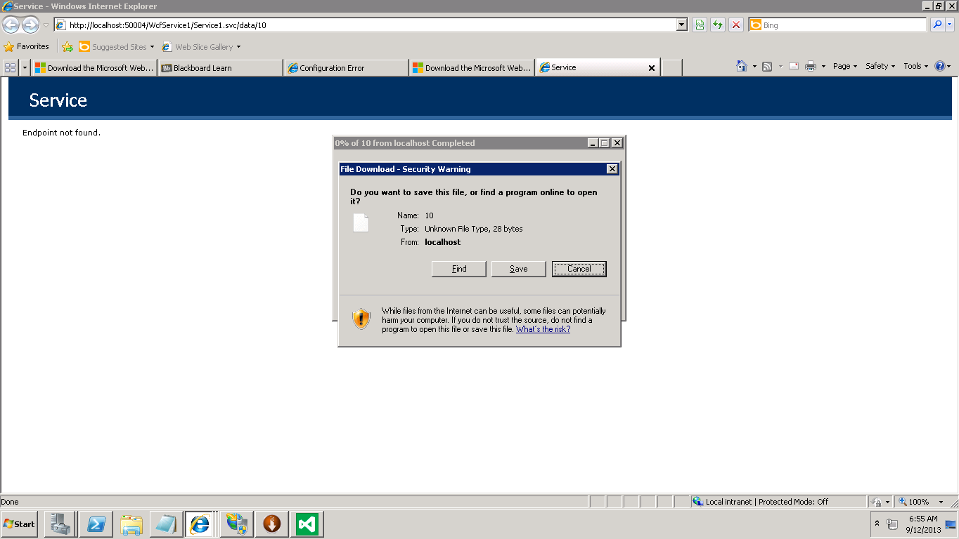

1. See Output file data

